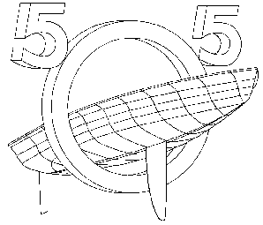International 505 Class Yacht Racing Association of Great Britain

Application for membership
Please complete this form and send it with a cheque, if applicable, to the Membership Secretary:
Mr D Cram, 4 Rozel Road, Horfield, Bristol, BS78SQ, or email it to membership@505news.co.uk
The Association is grateful if you can pay by Standing Order. Please complete the instruction on the bottom half of this form, detach it and SEND IT TO YOUR BANK.
I WISH TO RENEW / JOIN THE UK NATIONAL 505 CLASS ASSOCIATION FOR:
NAME:
Address:
Postcode:
Telephone: |  | Mobile:
Sailing Club: |  | Boat Number:
Email:
Please add my e-mail address to the 505 Newsletter list: YES/NO *
I agree to my details being published to other 505 GB association members: YES/NO *
I WISH TO PAY BY STANDING ORDER AND HAVE INSTRUCTED MY BANK ACCORDINGLY *
I ENCLOSE A CHEQUE MADE PAYABLE TO THE INTERNATIONAL 505 CLASS BRITISH ASSOCIATION FOR £
(FULL MEMBERSHIP £30 / ASSOCIATE £15 / CLASSIC £20) *
Type: Full/Associate/Classic * (Classic = Pre 8400, Training and UK Events Only)
SIGNED: |  |  | DATE:
* Please delete as appropriate
--------------------------------------------------------------------------------------------------------------------------------------
Standing Order Authority
To the Manager,
Bank: |  | Branch:
Address:
SORT CODE: |  | ACCOUNT NUMBER:
ACCOUNT NAME:
PAY TO: TSB Bank PLC, 198 Marlowes, Hemel Hempstead, Herts, HP1 1BH
ACCOUNT NAME: The International 505 Class British Association
SORT CODE: | 30-94-08 | ACCOUNT NUMBER: | 02676648
Please accept this authority to remit to the credit of the account of the International 505 Class British Association the sum of *£30.00 / £20.00 / £15.00, on …….…………, and the sum of *£30.00 / £20.00 / £15.00 on each successive 1st January until countermanded. This order replaces any previous instruction in favour of the recipient.
SIGNED: |  | DATE:

